Road Accident Risk Analysis

1. Project Overview
This project focuses on analyzing road accident data to identify high-risk locations, understand accident patterns, and evaluate key risk factors such as time, weather, traffic conditions, and vehicle involvement. The objective is to generate actionable insights to improve road safety and support data-driven decision-making.

2. Dataset Summary
Rows: 20000
Columns: 24
Key Features:
- Location: State, City, Latitude, Longitude
- Time: Date, Hour, Day of Week, Weekend, Peak Hour
- Environment: Weather, Visibility, Temperature
- Road: Road Type, Traffic Density, Lanes, Traffic Signal
- Accident: Cause, Severity, Vehicles Involved, Casualties
- Special: Festival
- Calculated: Risk Score

3. Exploratory Data Analysis using Python
We performed data pre-processing and exploration using Python:

● Data Loading
- Imported dataset using Pandas

● Initial Exploration
- Used .info() and .describe() to understand structure and statistics

● Data Cleaning
- Handled missing values
- Removed inconsistencies
- Standardized column names

● Feature Engineering
- Created:
  - Weekend Status
  - Peak hour status from is_peak_hour
  - Risk-based insights

● Data Validation
- Ensured data consistency across:
  - Location
  - Time
  - Risk factors

● Database Integration
- Loaded cleaned data into PostgreSQL for SQL-based analysis

4. Data Analysis using SQL (Business Problems)
We performed structured SQL analysis to answer key risk-related business questions:

1. Accident Hotspots
Identified the most accident-prone city in each state.
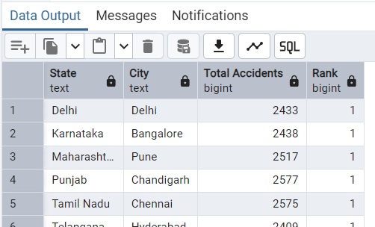

2. State-wise Risk Analysis
Calculated average risk score across states to identify high-risk regions.

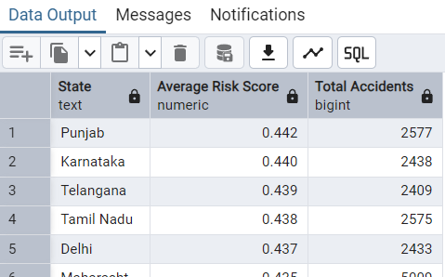

3. Accident Causes
Analysed major causes contributing to accidents.

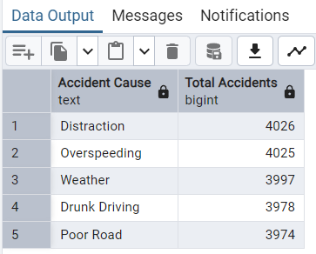

4. High-Risk Cities
Identified top cities with highest average accident risk.
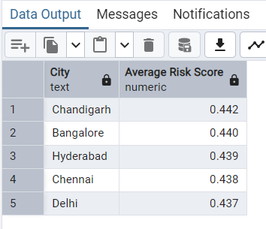

5. Vehicle-Based Risk
Evaluated how accident risk varies with number of vehicles involved.

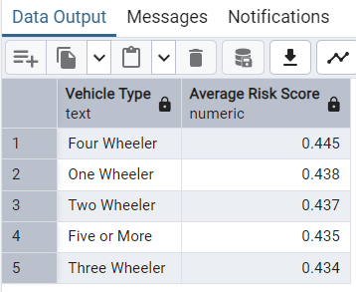

6. Weekend Urban Accidents
Measured accident frequency in urban areas during weekends.
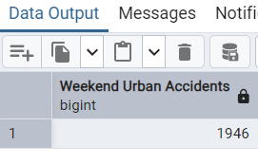

7. Peak Hour Analysis
Analysed accidents during peak traffic hours in urban area.
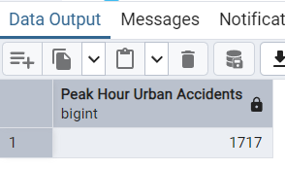

8. Fatal Accident Causes
Identified causes leading to fatal accidents.
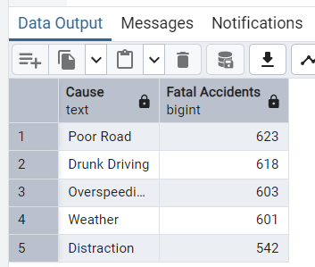

9. Festival vs Normal Days
Compared accident risk during festival and non-festival days.
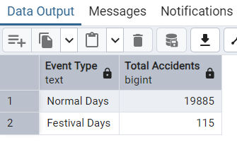

10. Day-wise Risk
Determined the most dangerous day of the week.
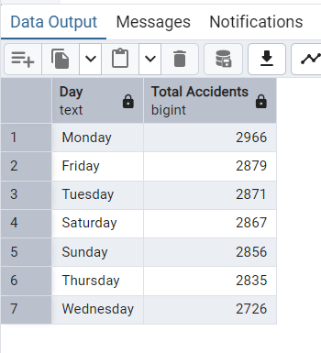

5. Dashboard in Power BI
An interactive dashboard was created to visualize insights:

Key Visuals:
- KPI Cards (Total Accidents, Avg Risk, Fatal Cases)
- Accident Hotspot Map (Latitude & Longitude)
- State-wise Risk Comparison
- Time-based Trends (Hour, Day)
- Cause Analysis
- Vehicle Risk Analysis
- Festival vs Normal Comparison

Features:
- Dynamic filters (State, Weather, Time)
- Risk-based color coding (Red–Yellow–Green)
- Multi-page navigation

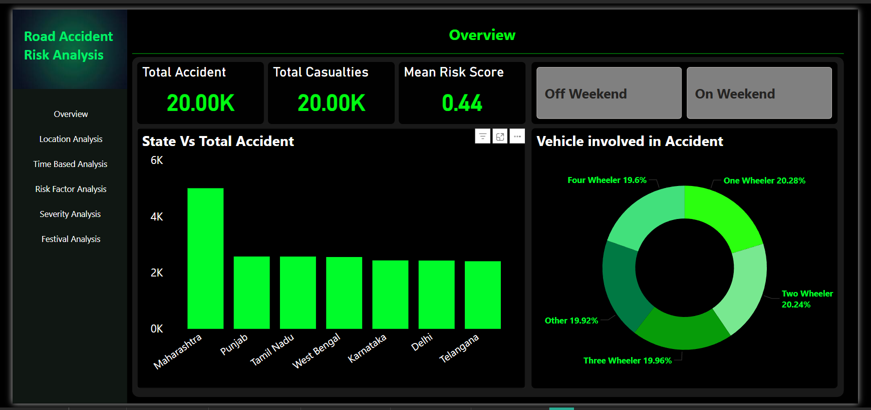
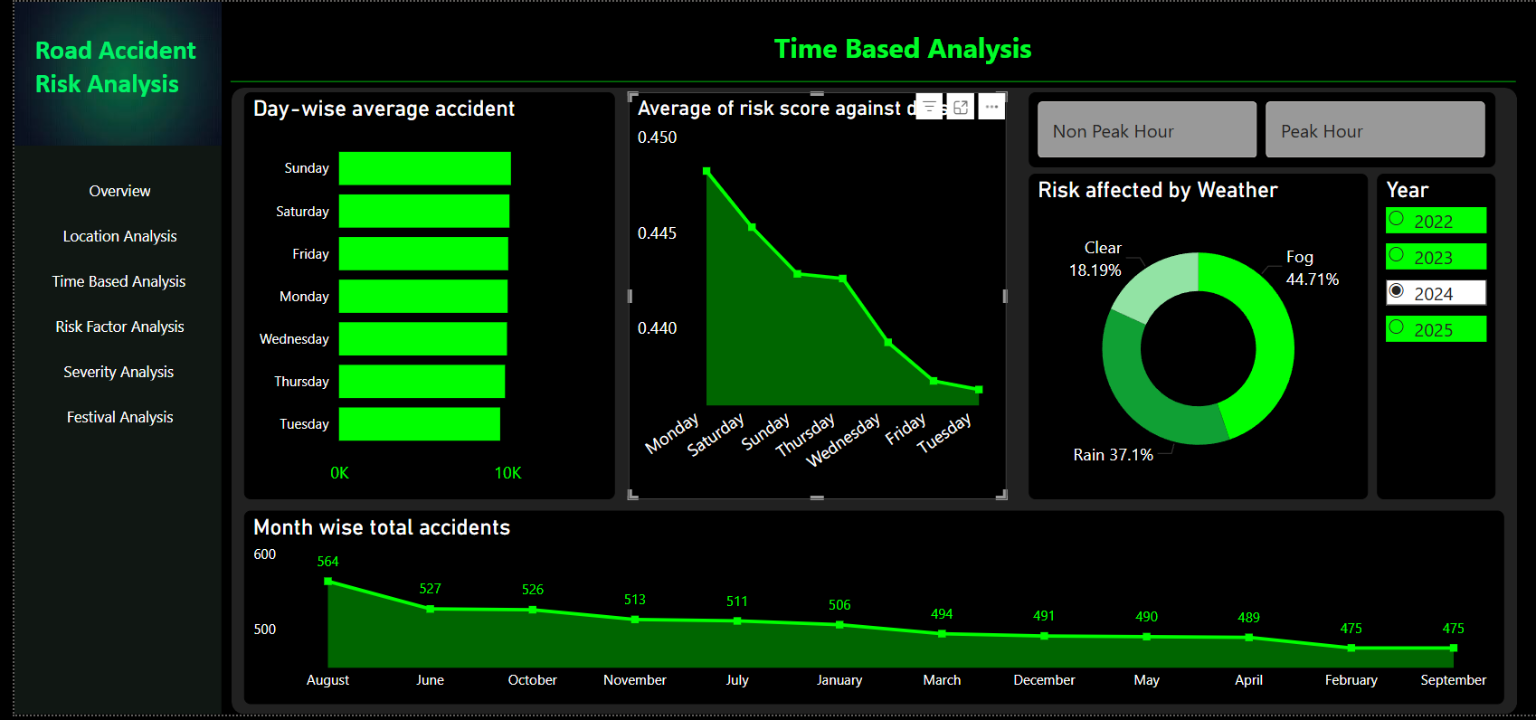
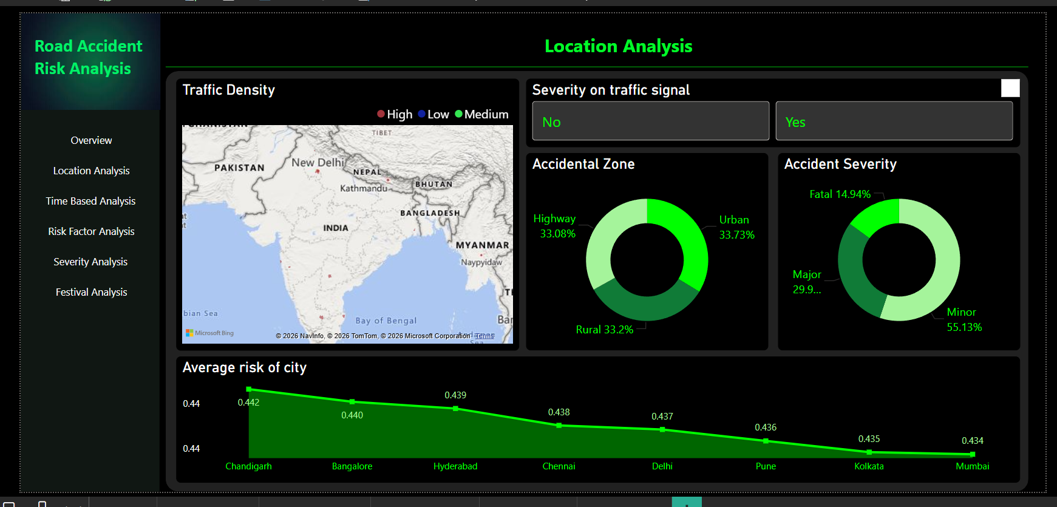
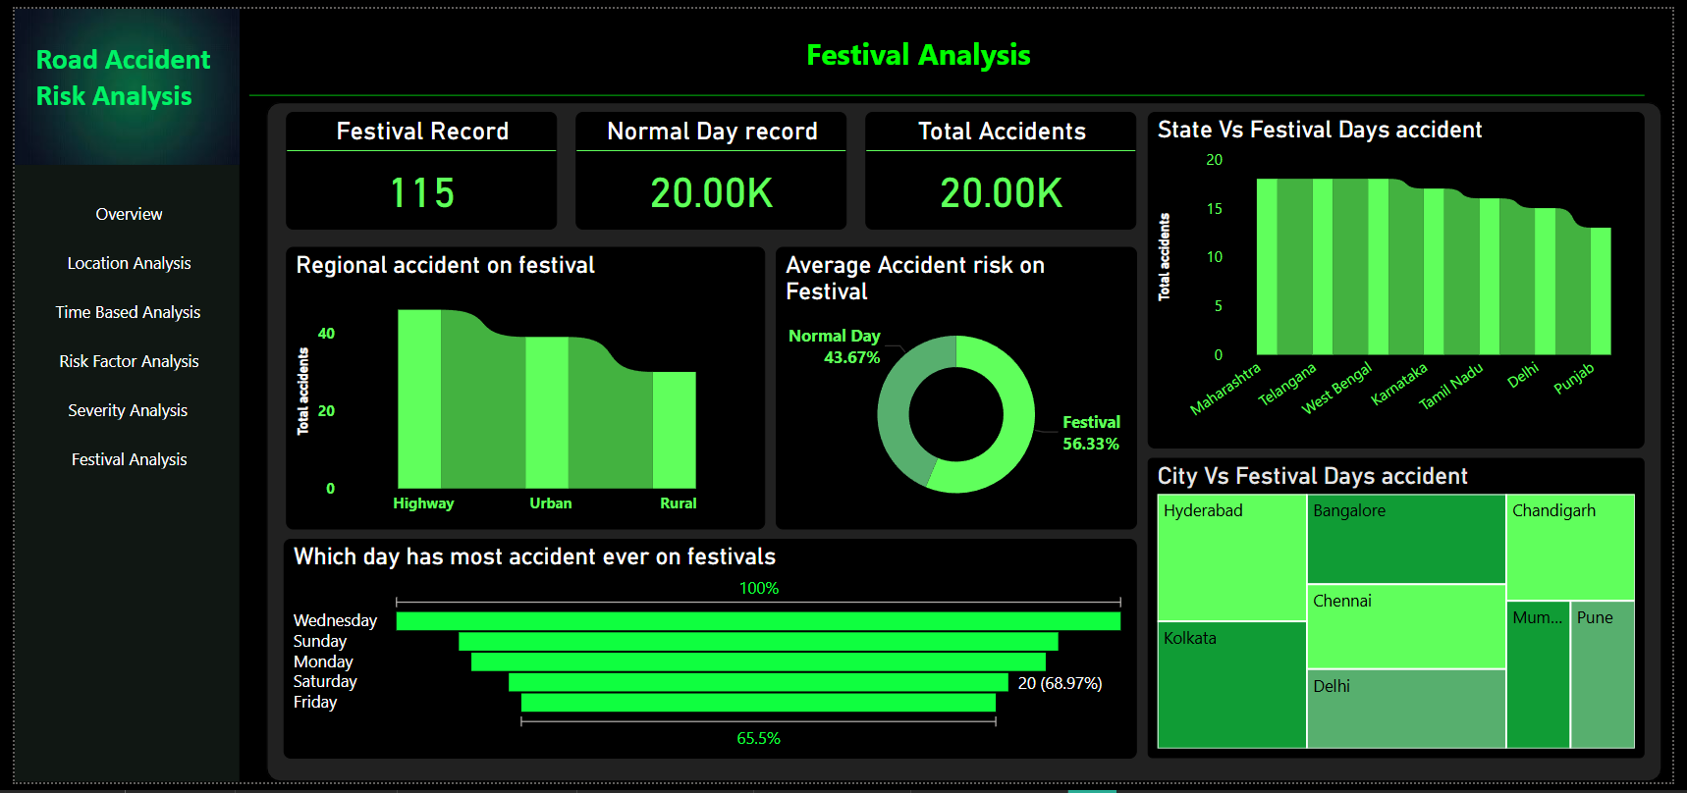
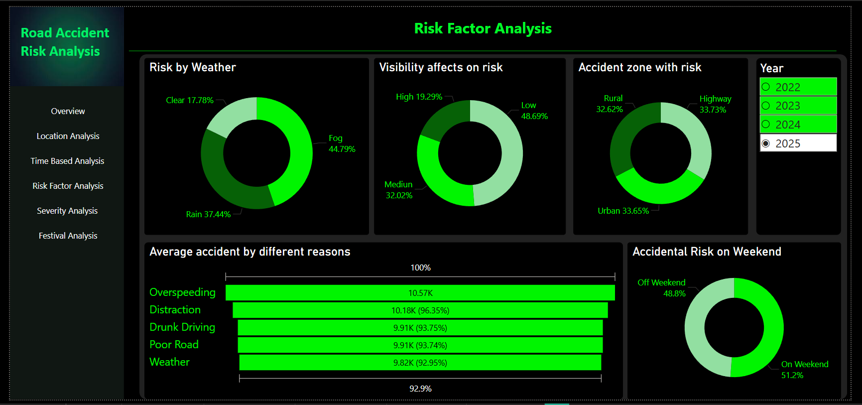
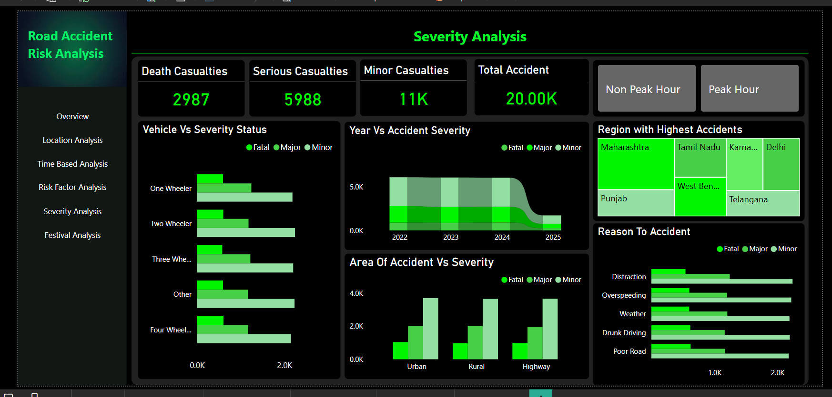

6. Business Recommendations

Improve High-Risk Areas
- Focus on accident hotspots with better infrastructure and monitoring

Traffic Management
- Implement stricter control during peak hours and weekends

Weather-Based Alerts
- Introduce warning systems during poor weather conditions

Vehicle Safety Policies
- Improve regulations for multi-vehicle traffic scenarios

Festival Traffic Planning
- Increase traffic control during festivals and public events

Awareness Campaigns
- Address major causes like over speeding and negligence

